Day - 5 MongoDB Assignment
1. Create Collection
InsuranceDB> db.createCollection('Policies')
{ ok: 1 }
2. Insert
Insert only one document:
db.policies.insertOne({ policy_id: 123, name: "Standard Liability Policy", customer_name: "John Doe", annual_income: 1000000, coverage_amouncoverage_amount: 5000000, premium: 500, extensions: { basic: 120, advanced: 150 }, status: "active" }, { policy_id: 124, name: "Extended Coverage Policy", customer_name: "Jane Smith", annual_income: 1500000, coverage_amount: 7000000, premium: 750, extensions: { basic: 150, advanced: 170 }, status: "pending" })

Insert multiple documents
db.policies.insertMany([
{ policy_id: 123, name: "Standard Liability Policy", customer_name: "John Doe", annual_income: 1000000, coverage_amouncoverage_amount: 5000000, premium: 500, extensions: { basic: 120, advanced: 150 }, status: "active" }, { policy_id: 124, name: "Extended Coverage Policy", customer_name: "Jane Smith", annual_income: 1500000, coverage_amount: 7000000, premium: 750, extensions: { basic: 150, advanced: 170 }, status: "pending" },
{ policy_id: 125, name: "Health Plus Policy", customer_name: "Alice Johnson", annual_income: 931237, coverage_amount: 3539180, premium: 882.19, extensextensions: { basic: 160.11, advanced: 186.19 }, status: "expired" },
{ policy_id: 126, name: "Standard Liability Policy", customer_name: "Bob Wilson", annual_income: 2143313, coverage_amount: 4277930, premium: 1029.76, extensions: { basic: 188.74, advanced: 246.01 }, status: "active" },
{ policy_id: 127, name: "Homeowners Basic Policy", customer_name: "Carol Davis", annual_income: 2300478, coverage_amount: 9304780, premium: 650.55, exextensions: { basic: 184.14, advanced: 126.79 }, status: "expired" },
{ policy_id: 128, name: "Health Plus Policy", customer_name: "David Brown", annual_income: 986014, coverage_amount: 7501939, premium: 461.55, extensioextensions: { basic: 181.7, advanced: 246.98 }, status: "expired" },
{ policy_id: 129, name: "Health Plus Policy", customer_name: "Eve Garcia", annual_income: 1592434, coverage_amount: 5281008, premium: 909.32, extensioextensions: { basic: 126.93, advanced: 142.61 }, status: "active" },
{ policy_id: 130, name: "Auto Comprehensive Policy", customer_name: "Frank Miller", annual_income: 1937275, coverage_amount: 6318465, premium: 383.18, extensions: { basic: 199.33, advanced: 213.74 }, status: "expired" },
])
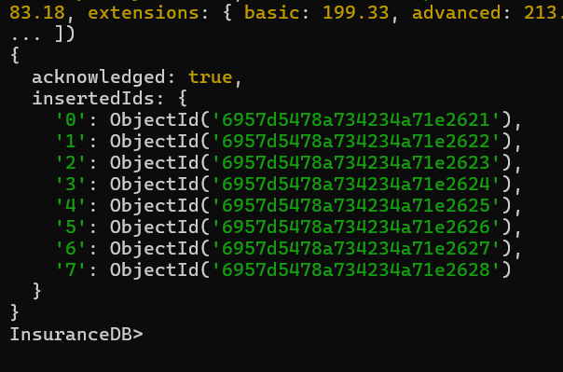

3.Update
Basic Syntax:
db.policies.updateOne({filter}, {update}, {options}) to target one document or db.policies.updateMany({filter}, {update}, {options}) to target multiple documents
Update policy 123 status and premium:
db.policies.updateOne(
{ policy_id: 123 },
{ $set: { status: "pending" }, $inc: { premium: 50 } }
)
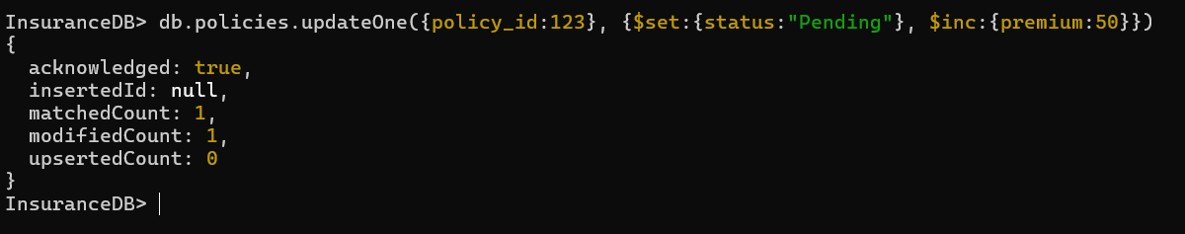

Update using upsert for new policy 131:
db.policies.updateOne({ policy_id: 131 },{ $set: { status: "active" } },{ upsert: true })
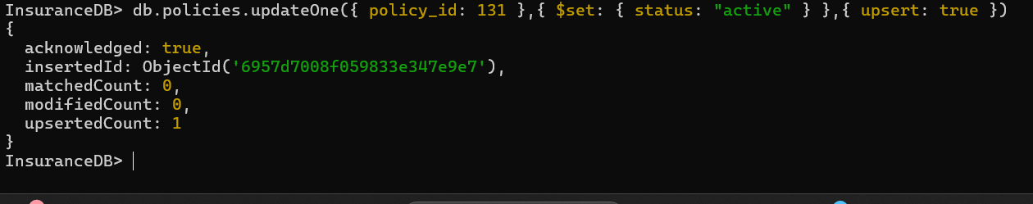

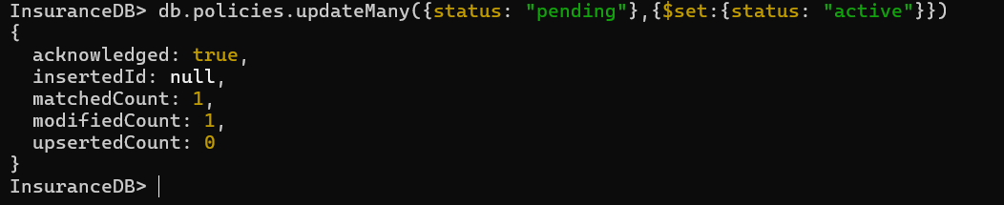
Activate all "pending" policies using updateMany:

Add a new field to all the documents:
db.policies.updateMany({}, {$set: {updatedAt: new Date()}})
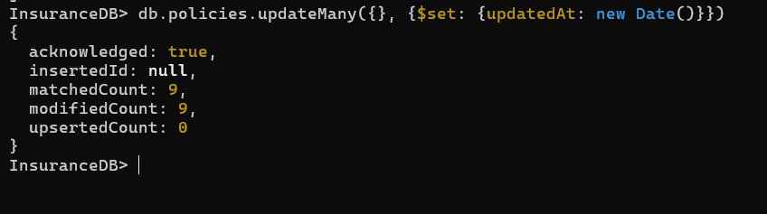

4.Projections (Read):
Show all documents:
db.policies.find({})
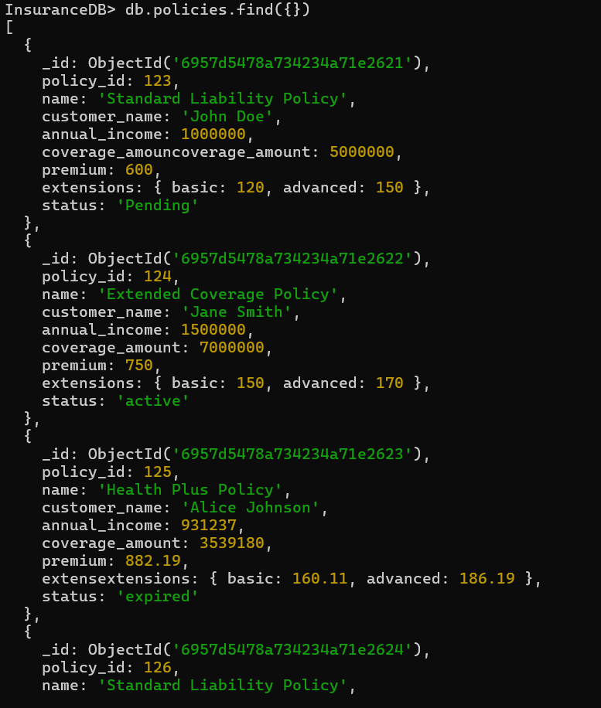

Show the document with policy_id:125:
db.policies.findOne({policy_id:134})
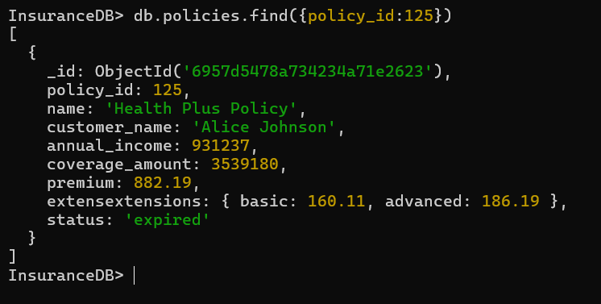

Show the selected fields only using projections:
db.policies.find({policy_id:{$gt:126}}, {_id:0, policy_id:1, name:1, customer_name:1, annual_income:1, coverage_amount:1})
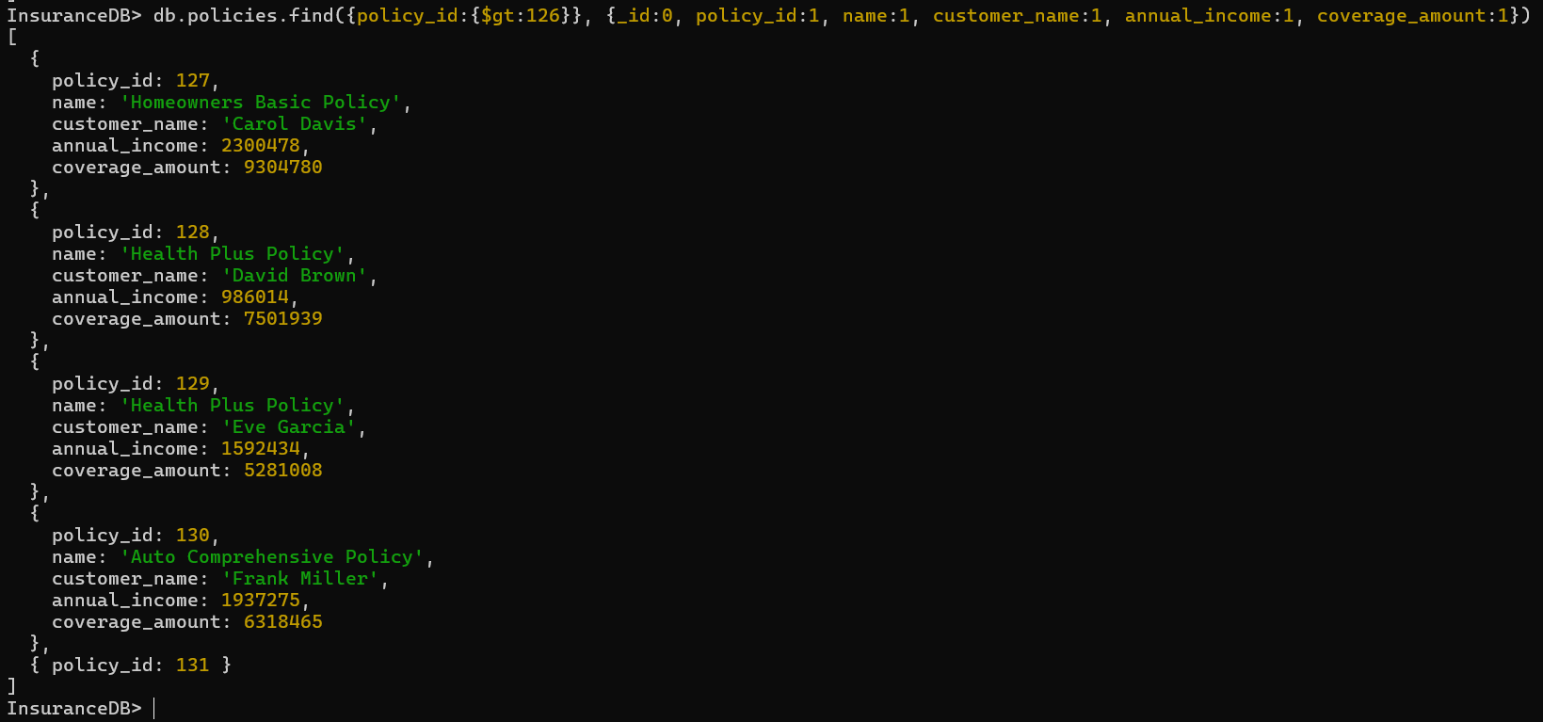

Show the documents in a sorted order of premium in descending order:
db.policies.find({status: "active"}).sort({premium: -1})
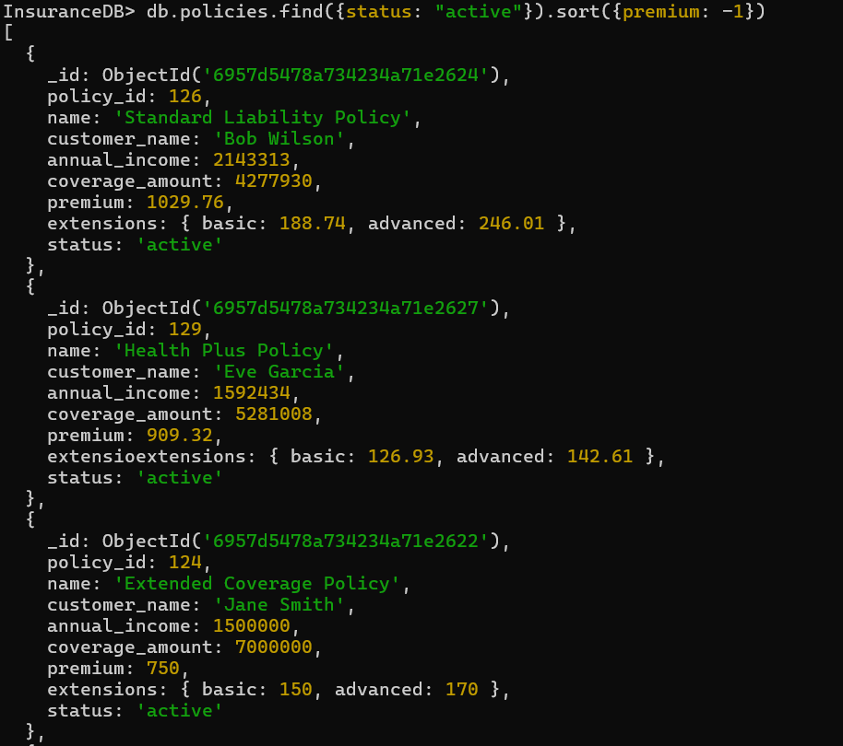

Show the documents in a sorted order of premium in ascending order:
db.policies.find({status: "active"}).sort({premium: 1})
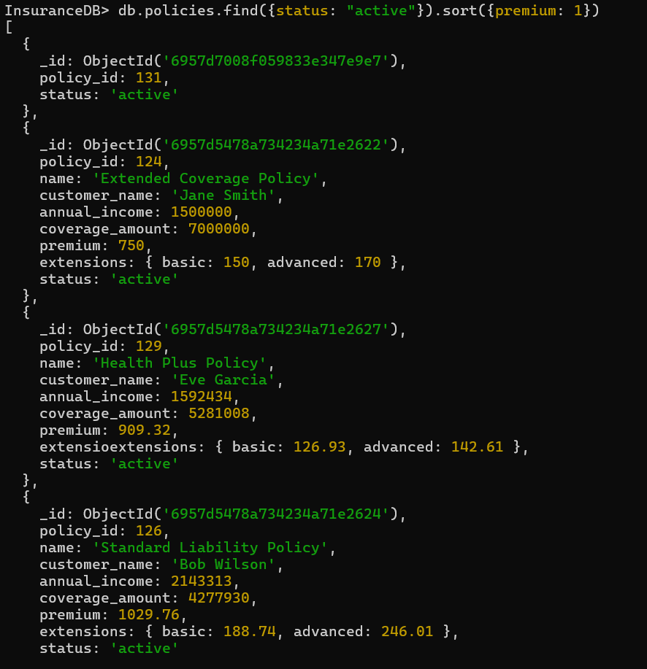

Show only first 3 documents:
db.policies.find().limit(3).pretty()
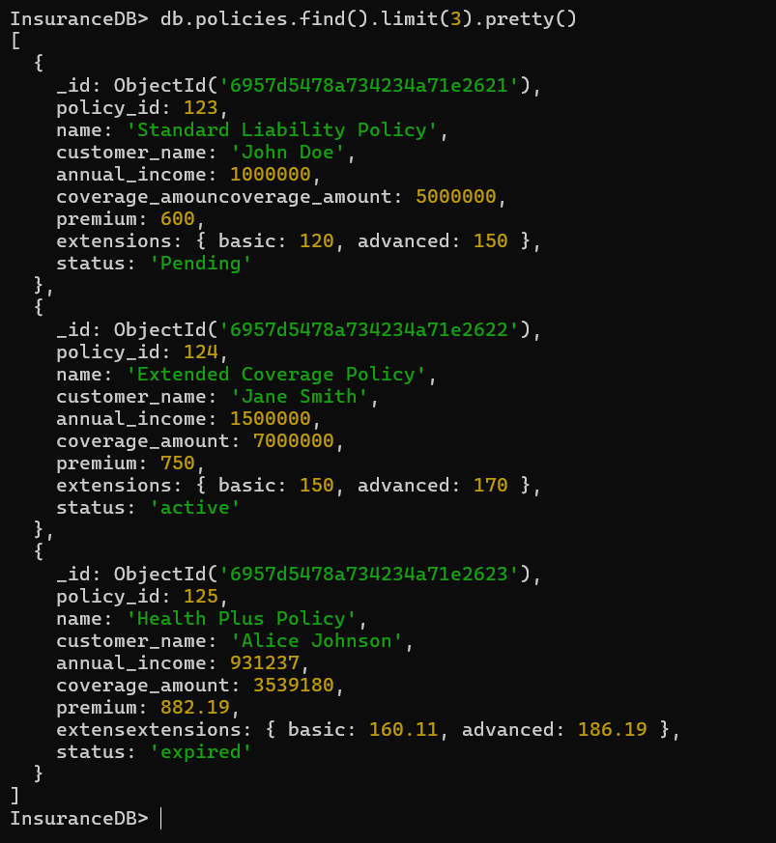

5. Aggregations:
Average premium by status:
db.policies.aggregate([{ $group: { _id: "$status", avgPremium: { $avg: "$premium" } } }])
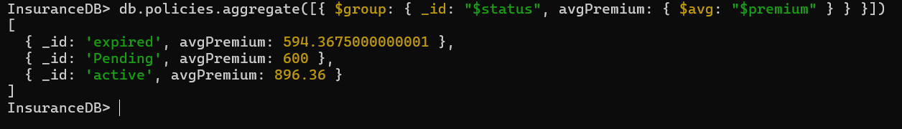
Current total policies:
db.policies.aggregate([{ $count: "total" }])
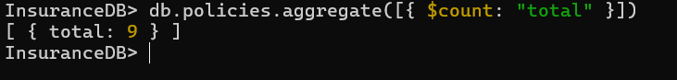
Group by status with counts:
db.policies.aggregate([{$group: { _id: "$status",count: { $sum: 1 }}}])
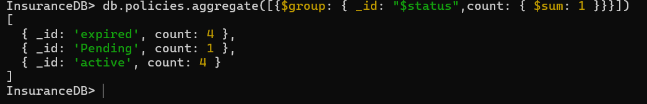

Filter active, then total premium:
db.policies.aggregate([{ $match: { status: "active" } },{$group: {_id: null,totalPremium: { $sum: "$premium" }}}])

Add coverage ratios to all policies:
db.policies.aggregate([{$addFields:{coverageRatio:{$divide:["$coverage_amount","$annual_income"]}}}]).pretty()
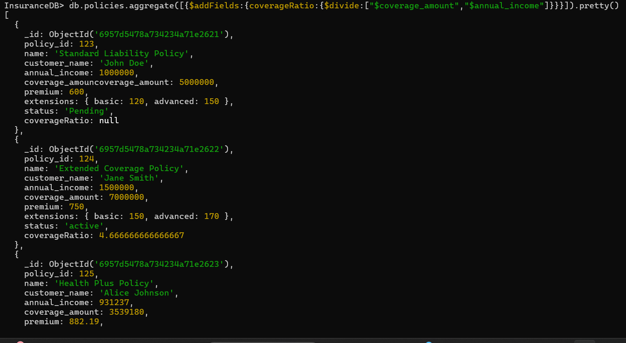

6. Logical Operators
Active or pending, high income:
db.policies.find({ $or: [ {status: "active"}, {status: "pending"} ], annual_income: { $gt: 1500000 } }).pretty()
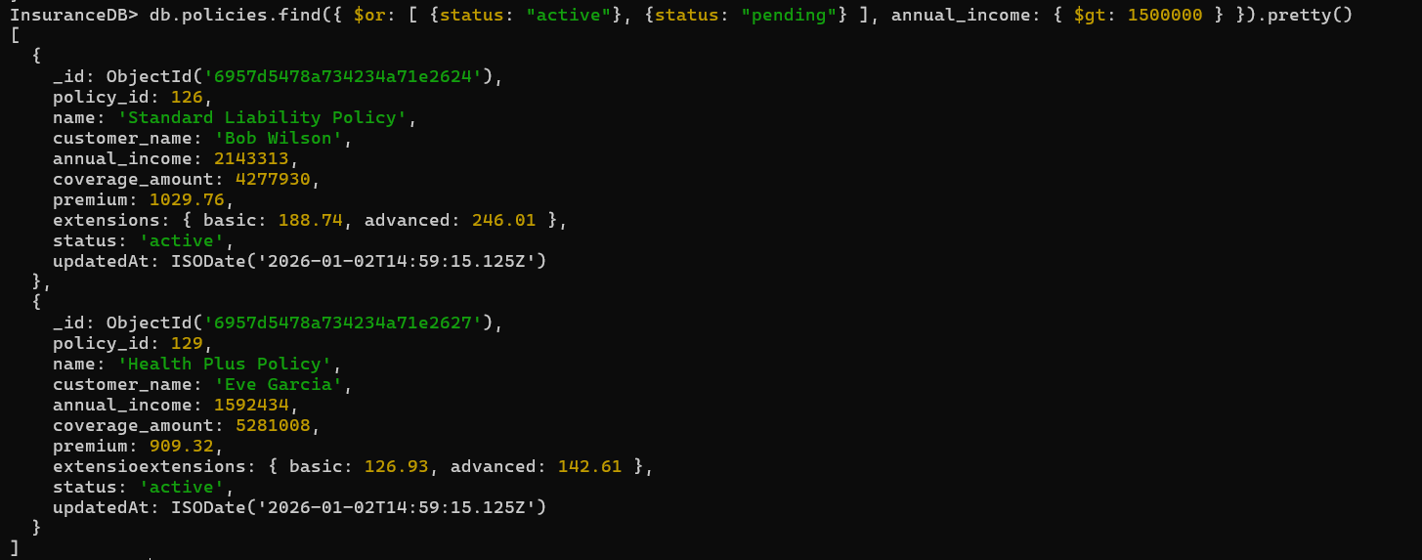

Expired AND low premium (under 600):
db.policies.find({ $and: [ {status: "expired"}, {premium: { $lt: 600 }} ] }).pretty()
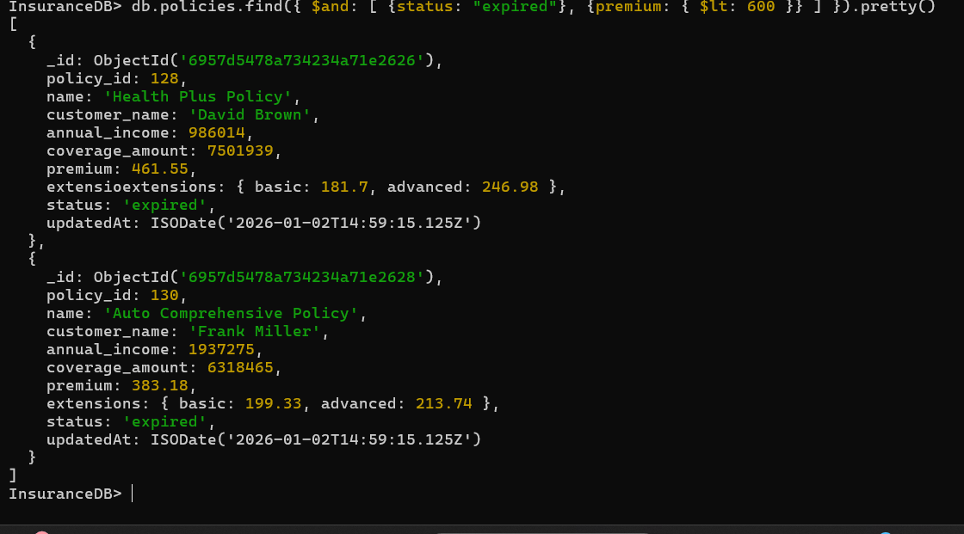
NOR: not active and not high coverage (>5M):
db.policies.find({ $nor: [ {status: "active"}, {coverage_amount: { $gt: 5000000 }} ] }).pretty()
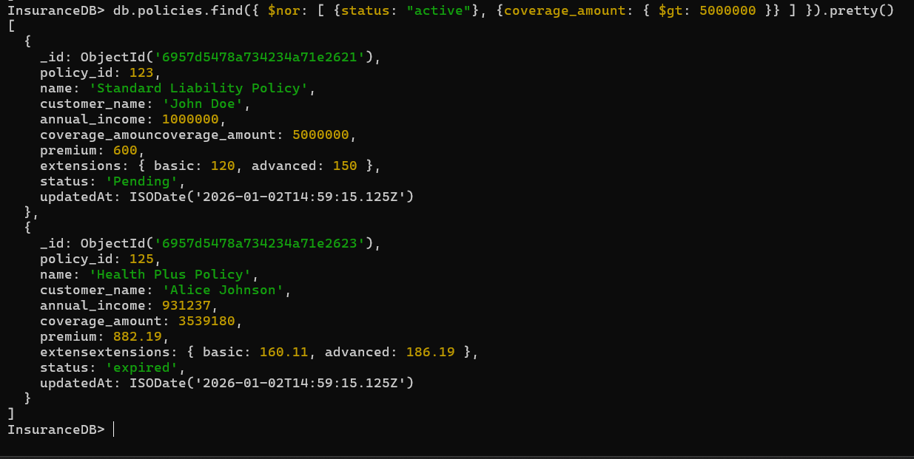

Active high premium avg:
db.policies.aggregate([{ $match: { $and: [ {status: "active"}, {premium: { $gt: 700 }} ] } },{ $group: { _id: null, avgPremium: { $avg: "$premium" } } }])

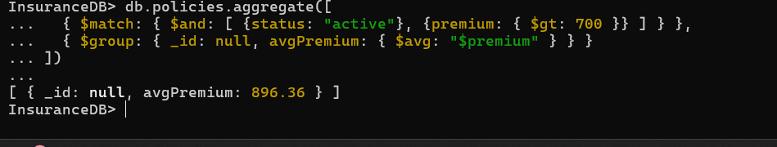

Lookup policies with same name (e.g., duplicates):
db.policies.aggregate([{$lookup:{from:"policies",localField:"name",foreignField:"name",as:"similarPolicies"}},{$limit:2}]).pretty()
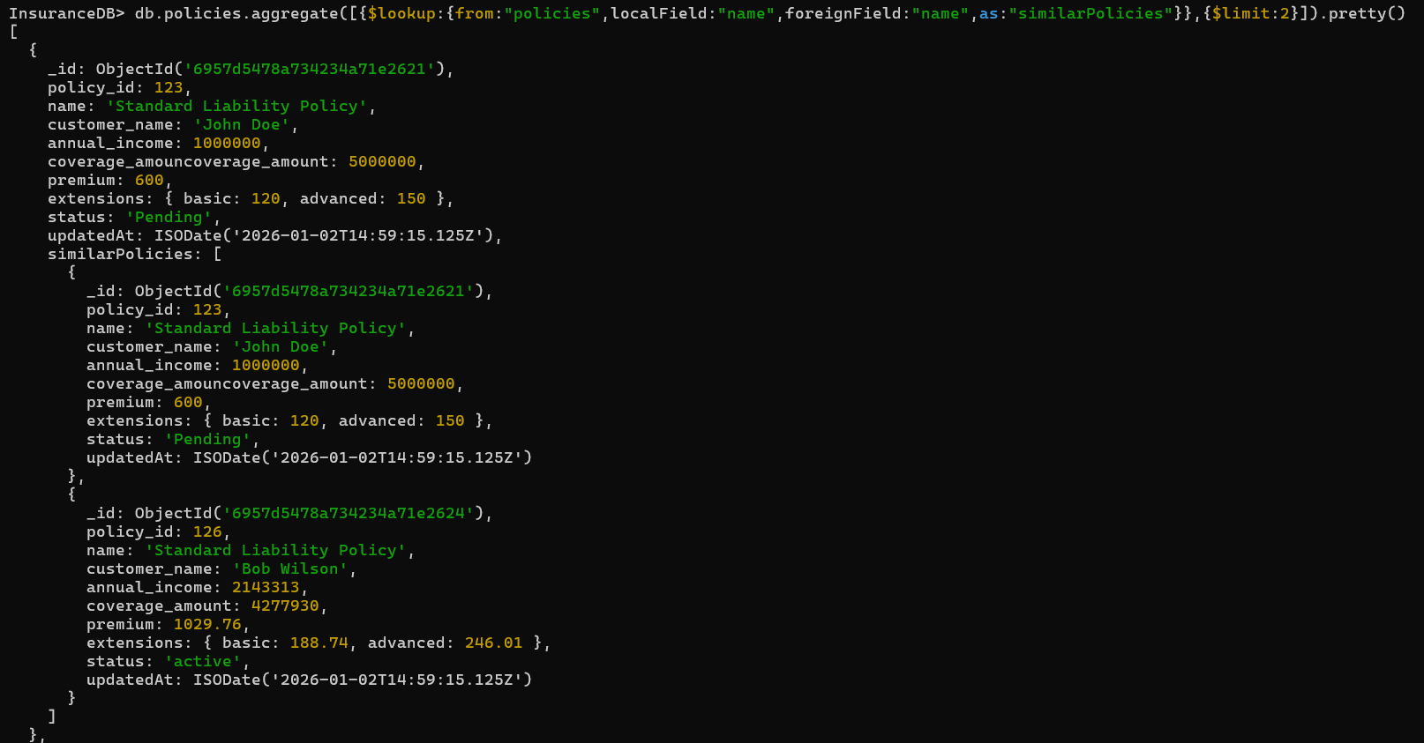

7. Delete
Delete first expired policy:
db.policies.deleteOne({status: "expired"})
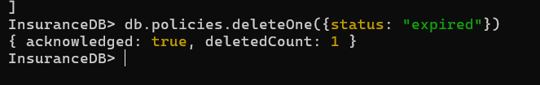

Delete specific ID:
db.policies.deleteOne({policy_id: 130})
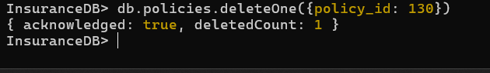

Return deleted doc:
db.policies.findOneAndDelete({status: "pending"})
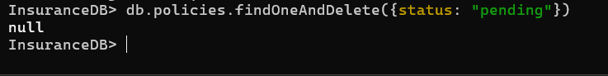

Delete all expired:
db.policies.deleteMany({status: "expired"})

Empty the collection:
db.policies.deleteMany({})
